AIRLINE BACKEND SYSTEM

Objective:
We need to build a backend system that can support different features for am airline company . Our end user is going to be someone who wants to book flight and query about flights a we need a robust system to actually help them to give them best experience possible. This doc is solely going to focus on the backend part of system . We want to prepare the whole backend keeping the fact in mid that the code should be maintainable as possible.

Requirements:
1. A user should be able to search for flights from one place to another.
- User should be able to mention the source and destination details.
- User should be able to select the dates of journey.
- [V2] User should be able to search for return and multicity flights
- User should be able to able to book class of flights [Not Mandatory]
- User should be able to select no of seats they want to book [Not Mandatory]
- Now based on above data we will list down the flights
- We should show our user the best available flights based on time period of flights and price of flights.
- We need to support paginaton so that we can list chunk of flights at one point of time.
- We should support filter of flights based on price,departure time , duration,airline and stops
- [V2] we can add support for more filters
2. A user should be able to book flights considering that user is register on platform.
- Users should be able to cancel a booking and then based on some criteria we can initiate a refund for them
- User should be able to request and book excess luggage for every flight.
3. For making a booking user has to make payment[dummy].
4. Tracking flight prices should be possible , the user should be notified about any price drops or any delays.
5. User should be able to list their previous and upcoming flights.
6. User should be able to download boarding pass if they have done online checking.
7. Online checking mechanism should be supported.
8. Notification via email for completing online check-in before 3 hours of departure.
9. Notification to users about any flight delay.
10. User should be able to review the flight journey only if they have booked a flight.
- The review mechanism should involve a star rating along with comments.
- while listing any flights we should also display the review of flights.
11. User should be able to authenticate to the user system using email and password.
- [V2] Support ticketing, where user can raise their queries
12. Listing FAQ which will be static data
-[V2] prepare the seat selection
13. Coupons for discounts and offers
14. While making booking a person can reserve more than one seats with one login id

NON FUNCTIONAL REQUIREMENTS
- We can expect that we are going to have more flight searches than flight bookings.
- The system needs to be accurate in terms of booking
- Expect that we will be having approx 1 lac users 5 lac booking might come in one quarter
- So in one day we can expect 10k bookings
- System should be capable of scaliling up to atleast 3x the current traffic.
- The system should provide real time updates to flight prices before user makes the final booking.
- Concurrency should be handled, using RDMS should be good solution
Capacity Estimation
- Storage estimations
- For upcoming 5 years, 80 lac bookings, 2 lac users , considering all the users record take 10 MB of data, then overall 10 TB of memory should be fine for our initial pilot run
- Traffic estimation: if we consider 30: 1 as the search booking ratio then at max we expect 150000 search queries a day.- 2 query per second.

Search and Flights Microservice
- Create Flights
- Delete Flights
- Update Flights
- Search for flights
- Based on multiple filtration criteria we can search for flights
- Pagination

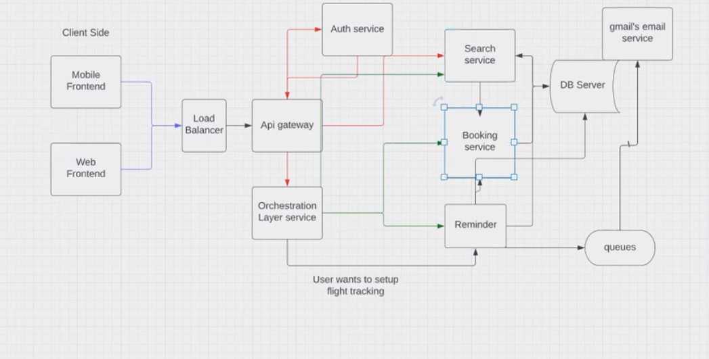

Flight-Search-Database-

